Introduction

Overview of the project
The Employee Record System is a Java-based project developed to manage employee information efficiently using a Hash Table. The system uses the Employee ID as a unique key to store and retrieve employee records quickly. Each record contains details such as ID, Name, Age, Qualification, Position, and Salary. The project uses a hash function to calculate the storage position and separate chaining to handle collisions when multiple employee IDs have the same index. It provides operations such as inserting, searching, updating, deleting, and displaying employee records, along with hash table statistics. The system also uses load factor monitoring and rehashing to maintain efficient performance as the number of employee records increases.

Purpose
The purpose of the Employee Record System is to provide an efficient way to store, manage, and retrieve employee information using a hash table. It aims to make operations such as insertion, searching, updating, and deletion faster by using the Employee ID as a unique key. The system also handles hash collisions using separate chaining and maintains efficient performance through load factor monitoring and rehashing.

Scope
The scope of the Employee Record System is to provide an efficient method for storing and managing employee records using a hash table. The system can perform operations such as inserting, searching, updating, deleting, and displaying employee records using Employee ID as the key. It also includes collision handling through separate chaining and rehashing based on the load factor to maintain efficient performance. The project can be further extended with features such as database integration, file storage, GUI, employee filtering, authentication, and exporting records to CSV or PDF.

Existing System
The existing system for managing employee records generally uses traditional methods such as manual records or sequential searching to store and retrieve employee information. As the number of employees increases, searching for a particular record can take more time because records may need to be checked one by one. Frequent operations such as insertion, searching, updating, and deletion can therefore become less efficient. The proposed Employee Record System improves this process by using a hash table with Employee ID as the key, allowing records to be accessed more efficiently

Proposed System
The proposed Emplo
yee Record System is a Java-based application that uses a Hash Table to store and manage employee records efficiently. Each employee is identified by a unique Employee ID, which is used by the hash function to determine the storage location. The system supports insertion, searching, updating, deletion, and displaying employee records. It uses separate chaining to handle collisions and monitors the load factor to perform rehashing when required. This provides an organized and efficient way to manage employee information.

Problem Statement
Managing a large number of employee records requires efficient storage and retrieval. If the records are kept in a simple list or array, finding one employee means checking the records one by one (sequential searching), and the time taken keeps growing as the number of records increases. An employee management system, however, needs to insert, search, update and delete records again and again, so slow access quickly becomes a problem.
A hash table can provide fast access by converting the Employee ID directly into a storage location. But a hash table brings its own challenges: two different IDs can map to the same location (a collision), and a table that becomes too full slows down. The problem addressed in this project is to design and implement a Java program that can:
Store employee records (ID, name, age, qualification, position, salary) in a hash table
Use the Employee ID as a unique key and reject duplicate IDs
Insert, search, update and delete records efficiently using the hash index
Handle collisions so that records are never lost or overwritten
Monitor the load factor and automatically enlarge the table (rehashing) when it becomes too full
Validate all user input and display statistics about the hash table
To solve this problem, the project implements the hash table from scratch as an array of buckets, where each bucket is the head of a doubly linked list of employee nodes. This approach ensures that:
Records are located directly through the hash index instead of scanning the whole collection
Colliding records share a bucket safely using separate chaining
Search time stays short because the table is rehashed before it gets crowded
Invalid or duplicate data is rejected before it enters the system
Thus, the project provides a practical and efficient solution for employee record management and a clear understanding of how hashing works internally

Defination
In every organisation, employee data such as identity numbers, names, qualifications, positions and salaries has to be stored and looked up many times a day. As the number of employees grows, the way this data is organised decides how quickly the required record can be found. Data structures are the tools used to organise data for exactly this purpose.
Among the many data structures, the hash table is one of the fastest for lookup by key. Instead of searching, it calculates the position of a record directly from its key using a hash function. In this project, the Employee ID is the key, and the hash function converts it into an index of the table. When two IDs produce the same index, the records are linked together in a chain – a technique called separate chaining.
The project is implemented in Java using an object-oriented design. Five classes work together: Employee stores one record, Node links records inside a bucket, EmployeeHashTable implements the hash table operations, Input validates what the user types, and EmployeeRecordSystem provides the menu-driven interface. The table starts small and grows automatically through rehashing, and a statistics option shows how the table is behaving – its size, load factor, collisions and longest chain.
Overall, this project demonstrates how hashing, linked lists, dynamic resizing and input validation can be combined into a working record-management application.

What is a Hash Table?
A hash table is a data structure that stores records using a key. It uses a hash function to convert the key into an integer called the hash index, and the record is stored in the location (bucket) with that index. Because the same calculation is repeated while searching, the required bucket can be reached directly without scanning the other records.
In this project, the Employee ID is the key. The hash function used is:
Index = Employee ID % Table Size
The program uses Java’s Math.floorMod(), which always returns a valid non-negative index between 0 and Table Size − 1. The table size is kept as a prime number (5, 11, 23, …) because a prime modulus spreads keys more evenly over the buckets and reduces collisions.
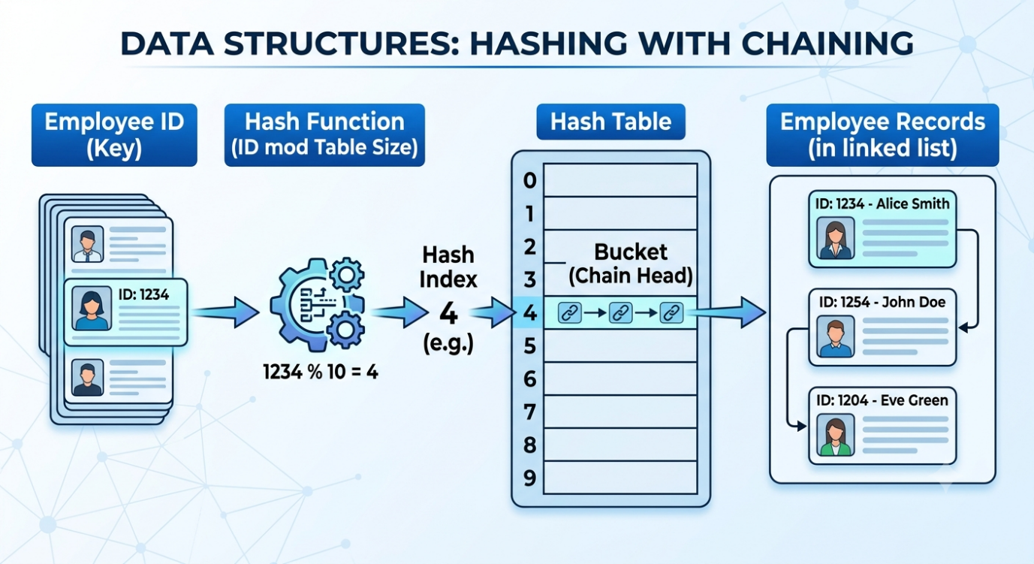

Hash Collisions and Their Resolution
A collision occurs when two different Employee IDs produce the same hash index. Records cannot simply replace one another, so every hash table needs a collision-resolution technique. The two common families are:

1. Separate Chaining (used in this project)
Each bucket is the head of a linked list (chain) of records
A new colliding record is added to the end of the existing chain
Searching traverses the chain until the required Employee ID is found
The table never becomes “full”; chains simply become longer

2. Open Addressing (not used)
All records are stored inside the table array itself
On a collision, another empty slot is probed (linear probing, quadratic probing or double hashing)
Needs special handling for deletion and slows down sharply as the table fills
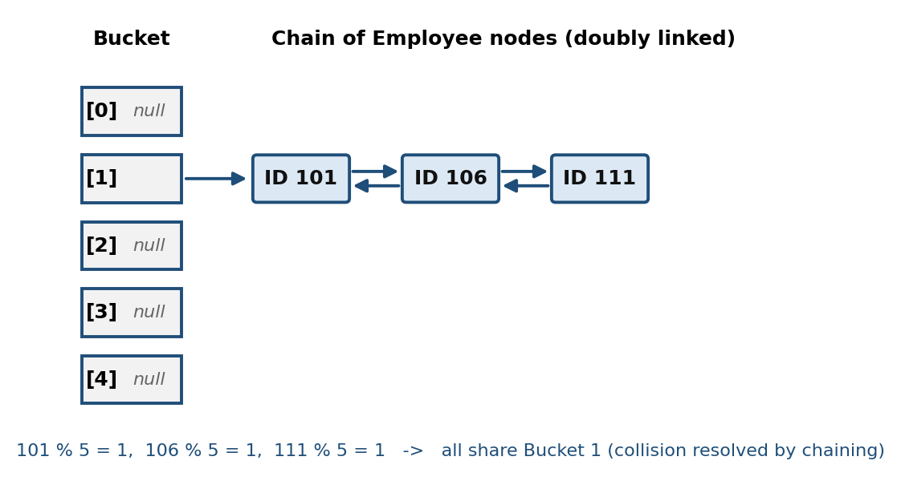
Figure:-Separate chaining – IDs 101, 106 and 111 share Bucket 1 (table size 5)
Here 101 % 5, 106 % 5 and 111 % 5 all equal 1, so the three records form one chain. The chain is a doubly linked list: every node keeps a reference to both the previous and the next node, which makes deleting a node from anywhere in the chain simple and fast.

Load Factor and Rehashing
The load factor is the ratio of the number of stored records to the number of buckets (Load Factor = Employee Count / Table Size). A low load factor means short chains and fast access; a high load factor means long chains and slow access. This system sets a maximum load factor of 0.75.
Before every insertion, the program checks whether (count + 1) / table size would exceed 0.75. If it would, the table is rehashed: a new table of roughly twice the size (the next prime number after 2 × old size + 1) is created, and every existing record is moved to its new position using the new table size. In the example below, inserting a fourth employee into a table of size 5 gives 4/5 = 0.80, which is above 0.75, so the table grows to size 11 and the records spread out.
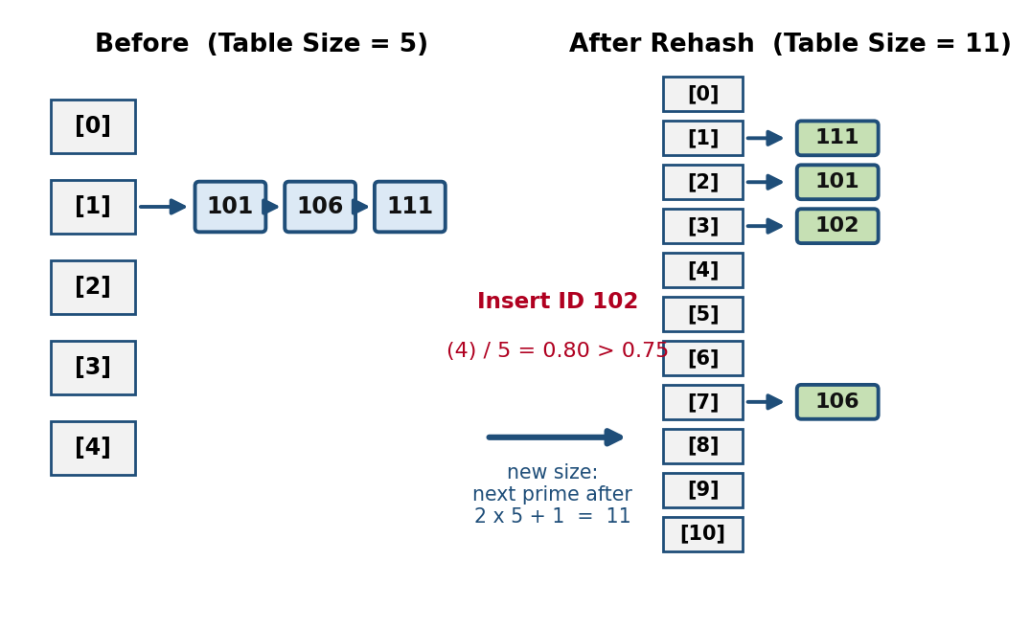
Figure 3: Rehashing – table grows from size 5 to 11 when the load factor limit is crossed

Why Use Hash Tables for Employee Records?
Fast access: an employee is located from the ID directly, in constant time on average, instead of by scanning all records
Unique key: an Employee ID naturally identifies exactly one employee, which suits hashing
Frequent operations: insertion, search, update and deletion are all needed constantly, and all of them use the same quick lookup
Scalability: with rehashing, performance stays good even when the number of employees grows
Simplicity: the idea is easy to implement and easy to explain compared with tree-based structures

Where Are Hash Tables Used?
Databases and Indexing – hash indexes allow quick record lookup by key
Language Libraries – Java’s HashMap and HashSet, Python’s dictionaries and sets
Compilers – symbol tables storing variable and function names
Caching – web and memory caches use keys to fetch stored results quickly
User and Account Management – finding a user, student or employee by ID or username
Networking – routing and lookup tables, and detecting duplicate items

Role of Java in This Project
Java is used to implement the entire system. Its features that were used are:
Classes and objects to model an employee, a node, the hash table and the user input
Encapsulation – private fields with getters and setters; the Employee ID is declared final so it can never change after creation
Arrays and object references to build the bucket array and the doubly linked chains
The Scanner class for reading input, and exception handling (try / catch) for validating it
Math.floorMod() for a safe hash index, and System.out for formatted console output

Algorithms and Tools Used
This project uses core data structures and algorithms in Java to store and manage employee records through a hash table with separate chaining.

Data Structures Used
Employee object – holds the ID, name, age, qualification, position and salary of one employee
Node (doubly linked list node) – holds an Employee and references to the previous and next node
Array of Node (the hash table) – each array position is a bucket holding the head of a chain

Algorithms Used

1. Hash Function
Index = floorMod(Employee ID, Table Size)
Purpose: converts the key into a bucket index; the same calculation is used for insert, search, update and delete

2. Insertion
Reject a null record or a duplicate ID
If (count + 1) / table size > 0.75, rehash first
Compute the index; place the node in the empty bucket, or (on a collision) append it to the end of the chain and increase the collision counter
Increase the employee count

3. Search
Compute the index, go to the bucket and traverse the chain comparing IDs
Return the record if found, otherwise report not found

4. Update
Search the record by ID; if found, replace name, age, qualification, position and salary (the ID itself is never changed)

5. Deletion
Traverse the chain to find the node
Re-link the previous and next nodes around it (or move the bucket head if it is the first node)
Detach the removed node and decrease the employee count

6. Display All and Statistics
Display All walks through every bucket and every chain, printing each record
Statistics counts non-empty buckets, finds the longest chain, and reports table size, employee count, load factor, collisions and rehash operations

7. Rehashing with Prime Table Size
New size = next prime after (2 × old size + 1); primality is tested by trial division up to √n
Every existing node is detached and re-inserted using the new table size

8. Input Validation
Name, qualification and position must not be empty
ID must be a non-negative number; age must be between 18 and 100; salary must be a finite non-negative number
Invalid input is rejected and the user is asked again

Tools Used
Java (JDK) – the language and compiler/runtime used to write and run the program (outputs in this report were produced on OpenJDK 21)
java.util.Scanner – console input
Math.floorMod() – hash index calculation
Console (terminal) – menu-driven interface and result display
class | purpose
Employee | Stores the details of one employee (ID, name, age, qualification, position, salary) and displays them
Node | Linked-list node holding an Employee with prev and next references
EmployeeHashTable | Implements the hash table: insert, search, update, delete, display, statistics and rehashing
Input | Reads and validates ID, age, salary and non-empty text from the user
EmployeeRecordSystem | Main class containing the menu loop and the operation methods

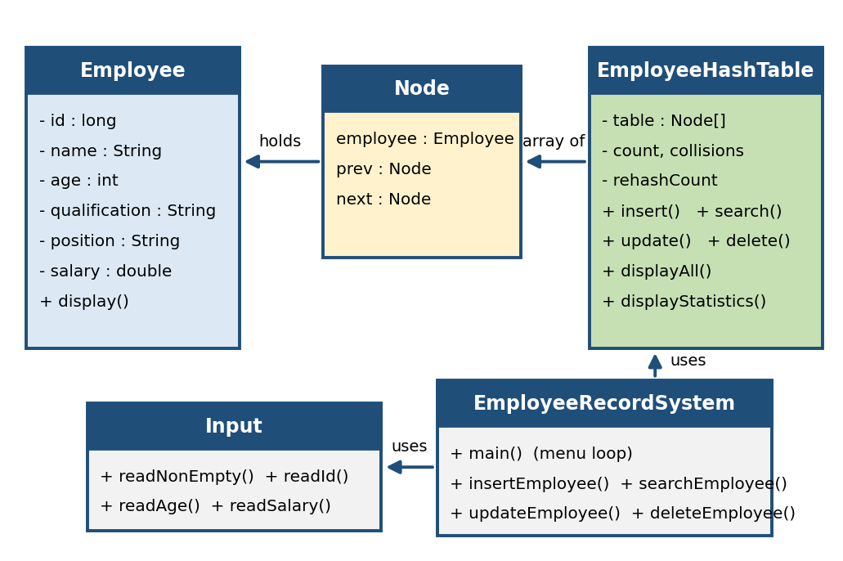

Program Flow
The program repeatedly displays the menu, reads a choice and performs the chosen operation until the user selects Exit. Every operation starts from the Employee ID: the hash index is calculated, the bucket is accessed and the chain is traversed if required.
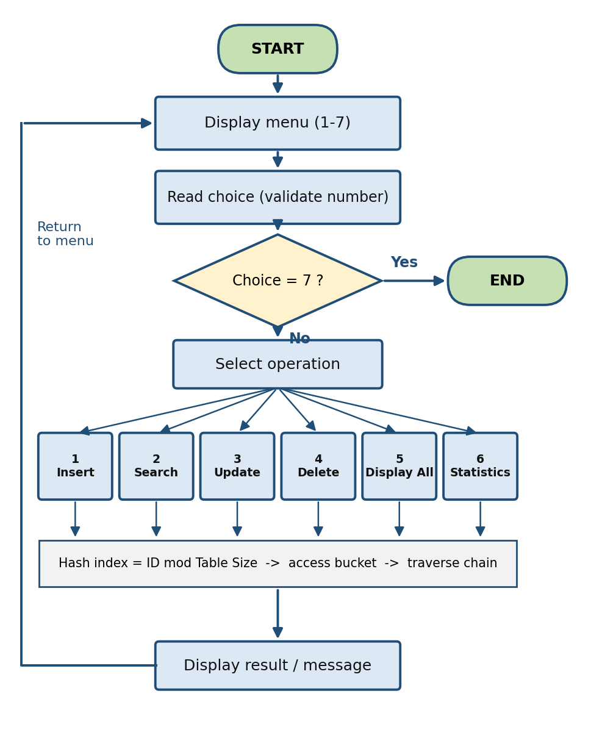
Figure 5: Flowchart of the Employee Record System

Menu Operations
Choice | Method | Description
1 | insertEmployee() | Reads the details, rejects a duplicate ID and inserts the record
2 | searchEmployee() | Finds a record by Employee ID and displays it
3 | updateEmployee() | Replaces the details of an existing employee
4 | deleteEmployee() | Removes a record from its chain
5 | displayAll() | Displays every record, bucket by bucket
6 | displayStatistics() | Shows table size, load factor, collisions, rehash count, longest chain
7 | Exit | Ends the program

Output screens

Test cases table
Test Case | Operation | Input | Expected Output | Status
TC01 | Insert | ID: 101, Name: Rahul, Age: 25 | Employee record inserted successfully | Pass
TC02 | Insert | ID: 106, Name: Rohan, Age: 26 | Employee record inserted successfully | Pass
TC03 | Search | Employee ID: 101 | Employee record found and displayed | Pass
TC04 | Search | Employee ID: 999 | Employee record not found | Pass
TC05 | Update | ID: 101, change name to Rohan | Employee details updated successfully | Pass
TC06 | Delete | Employee ID: 101 | Employee record deleted successfully | Pass
TC07 | Display | Display all records | All stored employee records displayed | Pass
TC08 | Collision | IDs 101, 106, 111 with table size 5 | Records stored in the same bucket using separate chaining | Pass
TC09 | Statistics | View hash table statistics | Table size, employee count, load factor and chain information displayed | Pass
TC10 | Rehashing | Insert records until load factor exceeds 0.75 | Hash table size increased and records rehashed | Pass

Conclusion

Summary of Achievements
The Employee Record System successfully achieved its main objective of developing an efficient employee record management system using a Hash Table. The project implemented insertion, searching, updating, deletion, and display of employee records using Employee ID as the key. It also successfully demonstrated hash functions, collision handling using separate chaining, load factor monitoring, and rehashing. The project provided practical experience in applying data structure concepts to a real-world employee management problem and improved the efficiency of storing and retrieving employee information.

Limitations of the System
The Employee Record System has some limitations. It is mainly a console-based Java application, so it does not provide a graphical user interface. The system currently stores employee records in memory, so the data may not be available after the program is closed. It does not include database integration, user authentication, or advanced filtering and reporting features. The system also does not provide direct export of employee records to formats such as CSV or PDF. These limitations can be addressed in future versions by adding database storage, a GUI, authentication, filtering, and data export features.

Future Enhancements
The Employee Record System can be improved in the future by adding database integration for permanent storage of employee records. A Graphical User Interface (GUI) can be developed to make the system more user-friendly. Other enhancements can include file storage, employee filtering and searching, user authentication, and exporting employee records to CSV or PDF formats. These features would make the system more useful, secure, and suitable for real-world employee management.

References
Data Structures and Algorithms Books
Java Programming Books
Online Tutorials
Programming Documentation
Java Documentation
OpenAI and Other AI Tools – Used for understanding concepts, debugging, and improving the implementation.

appendix
import java.util.Scanner;
class Employee
{
private final long id;
private String name;
private int age;
private String qualification;
private String position;
private double salary;
Employee(long id, String name, int age, String qualification, String position, double salary)
{
this.id=id;
this.name=name;
this.age=age;
this.qualification=qualification;
this.position=position;
this.salary=salary;
}
long getId()
{
return id;
}
String getName()
{
return name;
}
int getAge()
{
return age;
}
String getQualification()
{
return qualification;
}
String getPosition()
{
return position;
}
double getSalary()
{
return salary;
}
void setName(String name)
{
this.name=name;
}
void setAge(int age)
{
this.age=age;
}
void setQualification(String qualification)
{
this.qualification=qualification;
}
void setPosition(String position)
{
this.position=position;
}
void setSalary(double salary)
{
this.salary=salary;
}
void display()
{
System.out.println("ID : " + id);
System.out.println("Name : " + name);
System.out.println("Age : " + age);
System.out.println("Qualification : " + qualification);
System.out.println("Position : " + position);
System.out.println("Salary : " + salary);
System.out.println("-----------------------------------");
}
}

class Node
{
Employee employee;
Node prev;
Node next;
Node(Employee employee)
{
this.employee=employee;
}
}

class EmployeeHashTable
{
private Node[] table;
private int count;
private long collisions;
private int rehashCount;
private static final double MAX_LOAD_FACTOR = 0.75;
EmployeeHashTable(int size)
{
table=new Node[nextPrime(Math.max(3, size))];
}
private int hash(long id)
{
return Math.floorMod(id, table.length);
}
int size()
{
return count;
}
boolean insert(Employee employee)
{
if (employee==null)
return false;
if (search(employee.getId())!=null)
return false;
if ((double)(count + 1) / table.length > MAX_LOAD_FACTOR)
rehash();
int index=hash(employee.getId());
Node newNode=new Node(employee);
if (table[index]==null)
{
table[index]=newNode;
}
else
{
collisions++;
Node current=table[index];
while (current.next!=null)
current=current.next;
current.next=newNode;
newNode.prev=current;
}
count++;
return true;
}
Employee search(long id)
{
int index=hash(id);
Node current=table[index];
while (current!=null)
{
if (current.employee.getId()==id)
return current.employee;

current=current.next;
}
return null;
}
boolean update(long id, String name, int age, String qualification, String position,double salary)
{
Employee employee=search(id);
if (employee==null)
return false;
employee.setName(name);
employee.setAge(age);
employee.setQualification(qualification);
employee.setPosition(position);
employee.setSalary(salary);
return true;
}
boolean delete(long id)
{
int index=hash(id);
Node current=table[index];
while (current!=null)
{
if (current.employee.getId()==id)
{
if (current.prev!=null)
current.prev.next=current.next;
else
table[index] = current.next;
if (current.next!=null)
current.next.prev=current.prev;
current.prev=null;
current.next=null;
count--;
return true;
}
current=current.next;
}
return false;
}
void displayAll()
{
if (count==0)
{
System.out.println("No employee records found.");
return;
}
for (int i=0; i<table.length; i++)
{
Node current=table[i];
while (current!=null)
{
current.employee.display();
current=current.next;
}
}
}
void displayStatistics()
{
int nonEmptyBuckets=0;
int maxChain=0;
for (int i=0; i<table.length; i++)
{
int chainLength=0;
Node current=table[i];
while (current!=null)
{
chainLength++;
current=current.next;
}
if (chainLength > 0)
nonEmptyBuckets++;
if (chainLength > maxChain)
maxChain=chainLength;
}
double loadFactor = (double) count / table.length;
System.out.println("\n========== HASH TABLE STATISTICS ==========");
System.out.println("Table Size : " + table.length);
System.out.println("Employee Count : " + count);
System.out.println("Load Factor : " + loadFactor);
System.out.println("Non-Empty Buckets: " + nonEmptyBuckets);
System.out.println("Collisions : " + collisions);
System.out.println("Rehash Operations: " + rehashCount);
System.out.println("Maximum Chain : " + maxChain);
System.out.println("===========================================\n");
}
private void rehash()
{
Node[] oldTable=table;
table=new Node[nextPrime(oldTable.length * 2 + 1)];
for (Node head : oldTable)
{
Node current=head;
while (current!=null)
{
Node nextNode=current.next;
current.prev=null;
current.next=null;
int index=hash(current.employee.getId());
if (table[index]==null)
{
table[index]=current;
}
else
{
Node last=table[index];
while (last.next!=null)
last=last.next;

last.next=current;
current.prev=last;
}
current=nextNode;
}
}
rehashCount++;
}
private boolean isPrime(int number)
{
if (number<2)
return false;
if (number==2)
return true;
if (number % 2==0)
return false;
for (int i=3;i<=number / i;i+=2)
{
if (number % i==0)
return false;
}
return true;
}
private int nextPrime(int number)
{
while (!isPrime(number))
number++;

return number;
}
}

class Input
{
static String readNonEmpty(Scanner sc, String message)
{
while (true)
{
System.out.print(message);
String value=sc.nextLine().trim();

if (!value.isEmpty())
return value;

System.out.println("Value cannot be empty.");
}
}
static long readId(Scanner sc)
{
while (true)
{
try
{
System.out.print("Enter Employee ID: ");
long id=Long.parseLong(sc.nextLine().trim());
if (id>=0)
return id;

System.out.println("ID cannot be negative.");
}
catch (Exception e)
{
System.out.println("Enter a valid numeric ID.");
}
}
}
static int readAge(Scanner sc)
{
while (true)
{
try
{
System.out.print("Enter Age: ");
int age=Integer.parseInt(sc.nextLine().trim());

if (age>=18 && age<=100)
return age;
System.out.println("Age must be between 18 and 100.");
}
catch (Exception e)
{
System.out.println("Enter a valid age.");
}
}
}
static double readSalary(Scanner sc)
{
while (true)
{
try
{
System.out.print("Enter Salary: ");
double salary=Double.parseDouble(sc.nextLine().trim());
if (Double.isFinite(salary) && salary >= 0)
return salary;

System.out.println("Salary must be non-negative.");
}
catch (Exception e)
{
System.out.println("Enter a valid salary.");
}
}
}
}

public class EmployeeRecordSystem
{
static Scanner sc=new Scanner(System.in);
static EmployeeHashTable hashTable=new EmployeeHashTable(5);
public static void main(String[] args)
{
while (true)
{
System.out.println("\n========== EMPLOYEE RECORD SYSTEM ==========");
System.out.println("1. Insert Employee");
System.out.println("2. Search Employee");
System.out.println("3. Update Employee");
System.out.println("4. Delete Employee");
System.out.println("5. Display All Employees");
System.out.println("6. Hash Table Statistics");
System.out.println("7. Exit");
System.out.println("============================================");
System.out.print("Enter your choice: ");
int choice;
try
{
choice=Integer.parseInt(sc.nextLine().trim());
}
catch (Exception e)
{
System.out.println("Enter a valid choice.");
continue;
}
switch (choice)
{
case 1:
insertEmployee();
break;
case 2:
searchEmployee();
break;
case 3:
updateEmployee();
break;
case 4:
deleteEmployee();
break;
case 5:
hashTable.displayAll();
break;
case 6:
hashTable.displayStatistics();
break;

case 7:
System.out.println("Program terminated.");
return;

default:
System.out.println("Invalid choice.");
}
}
}
static void insertEmployee()
{
long id=Input.readId(sc);
if (hashTable.search(id) != null)
{
System.out.println("Employee ID already exists.");
return;
}
String name=Input.readNonEmpty(sc, "Enter Name: ");
int age=Input.readAge(sc);
String qualification=Input.readNonEmpty(sc, "Enter Qualification: ");
String position=Input.readNonEmpty(sc, "Enter Position: ");
double salary=Input.readSalary(sc);
Employee employee=new Employee(id, name, age, qualification, position, salary);
if (hashTable.insert(employee))
System.out.println("Employee inserted successfully.");
else
System.out.println("Employee insertion failed.");
}
static void searchEmployee()
{
long id=Input.readId(sc);

Employee employee=hashTable.search(id);

if (employee !=null)
{
System.out.println("\nEmployee Found:");
employee.display();
}
else
{
System.out.println("Employee not found.");
}
}
static void updateEmployee()
{
long id=Input.readId(sc);
if (hashTable.search(id)==null)
{
System.out.println("Employee not found.");
return;
}
String name=Input.readNonEmpty(sc, "Enter New Name: ");
int age=Input.readAge(sc);
String qualification=Input.readNonEmpty(sc, "Enter New Qualification: ");
String position=Input.readNonEmpty(sc, "Enter New Position: ");

double salary=Input.readSalary(sc);
if (hashTable.update( id, name, age, qualification, position, salary))
{
System.out.println("Employee updated successfully.");
}
else
{
System.out.println("Update failed.");
}
}
static void deleteEmployee()
{
long id=Input.readId(sc);
if (hashTable.delete(id))
System.out.println("Employee deleted successfully.");
else
System.out.println("Employee not found.");
}
}
Output :
========== EMPLOYEE RECORD SYSTEM ==========
1. Insert Employee
2. Search Employee
3. Update Employee
4. Delete Employee
5. Display All Employees
6. Hash Table Statistics
7. Exit
============================================
Enter your choice: 1
Enter Employee ID: 5
Enter Name: Rahul
Enter Age: 22
Enter Qualification: B.Tech
Enter Position: Software Engineer
Enter Salary: 45000
Employee inserted successfully.
========== EMPLOYEE RECORD SYSTEM ==========
1. Insert Employee
2. Search Employee
3. Update Employee
4. Delete Employee
5. Display All Employees
6. Hash Table Statistics
7. Exit
============================================
Enter your choice: 1
Enter Employee ID: 10
Enter Name: Priya
Enter Age: 23
Enter Qualification: B.Tech
Enter Position: Developer
Enter Salary: 50000
Employee inserted successfully.
========== EMPLOYEE RECORD SYSTEM ==========
1. Insert Employee
2. Search Employee
3. Update Employee
4. Delete Employee
5. Display All Employees
6. Hash Table Statistics
7. Exit
============================================
Enter your choice: 1
Enter Employee ID: 15
Enter Name: Arjun
Enter Age: 24
Enter Qualification: M.Tech
Enter Position: Team Lead
Enter Salary: 70000
Employee inserted successfully.
========== EMPLOYEE RECORD SYSTEM ==========
1. Insert Employee
2. Search Employee
3. Update Employee
4. Delete Employee
5. Display All Employees
6. Hash Table Statistics
7. Exit
============================================
Enter your choice: 2
Enter Employee ID: 10
Employee Found:
ID : 10
Name : Priya
Age : 23
Qualification : B.Tech
Position : Developer
Salary : 50000.0
-----------------------------------
========== EMPLOYEE RECORD SYSTEM ==========
1. Insert Employee
2. Search Employee
3. Update Employee
4. Delete Employee
5. Display All Employees
6. Hash Table Statistics
7. Exit
============================================
Enter your choice: 3
Enter Employee ID: 10
Enter New Name: Priya Sharma
Enter Age: 24
Enter New Qualification: M.Tech
Enter New Position: Senior Developer
Enter Salary: 65000
Employee updated successfully.
========== EMPLOYEE RECORD SYSTEM ==========
1. Insert Employee
2. Search Employee
3. Update Employee
4. Delete Employee
5. Display All Employees
6. Hash Table Statistics
7. Exit
============================================
Enter your choice: 5
ID : 5
Name : Rahul
Age : 22
Qualification : B.Tech
Position : Software Engineer
Salary : 45000.0
-----------------------------------
ID : 10
Name : Priya Sharma
Age : 24
Qualification : M.Tech
Position : Senior Developer
Salary : 65000.0
-----------------------------------
ID : 15
Name : Arjun
Age : 24
Qualification : M.Tech
Position : Team Lead
Salary : 70000.0
-----------------------------------
========== EMPLOYEE RECORD SYSTEM ==========
1. Insert Employee
2. Search Employee
3. Update Employee
4. Delete Employee
5. Display All Employees
6. Hash Table Statistics
7. Exit
============================================
Enter your choice: 6
========== HASH TABLE STATISTICS ==========
Table Size : 11
Employee Count : 3
Load Factor : 0.2727272727272727
Non-Empty Buckets: 3
Collisions : 0
Rehash Operations: 1
Maximum Chain : 1
===========================================
========== EMPLOYEE RECORD SYSTEM ==========
1. Insert Employee
2. Search Employee
3. Update Employee
4. Delete Employee
5. Display All Employees
6. Hash Table Statistics
7. Exit
============================================

Enter your choice: 4
Enter Employee ID: 10
Employee deleted successfully.
========== EMPLOYEE RECORD SYSTEM ==========
1. Insert Employee
2. Search Employee
3. Update Employee
4. Delete Employee
5. Display All Employees
6. Hash Table Statistics
7. Exit
============================================
Enter your choice: 2
Enter Employee ID: 10
Employee not found.
========== EMPLOYEE RECORD SYSTEM ==========
1. Insert Employee
2. Search Employee
3. Update Employee
4. Delete Employee
5. Display All Employees
6. Hash Table Statistics
7. Exit
============================================
Enter your choice: 1
Enter Employee ID: 5
Employee ID already exists.
========== EMPLOYEE RECORD SYSTEM ==========
1. Insert Employee
2. Search Employee
3. Update Employee
4. Delete Employee
5. Display All Employees
6. Hash Table Statistics
7. Exit
============================================
Enter your choice: 7
Program terminated.

